CLUSTERING ANALYSIS OF STUDENT PERFORMANCE USING K-MEANS
Virtual Data Science with Python Trainee Internship

Task 3. Project Report:
Project Title: Unsupervised Machine Learning
Virtual Data Science with Python Internship
Submitted by: SNEHA YADAV
Course: Bachelor of Computer Applications (BCA)
University: Babasaheb Bhimrao Ambedkar University
Internship Organization: yuvaintern
Internship Program: Virtual Data Science with Python Trainee
Submission Date: 26-10-2026

Project Overview
This project applies the K-Means clustering algorithm to student performance data to identify groups of students with similar study habits, attendance patterns, past failures, and academic grades.
The project demonstrates the practical application of unsupervised machine learning using Python, Pandas, Matplotlib, Seaborn, and Scikit-learn.

1. Abstract
Clustering is an unsupervised machine learning technique used to identify groups of similar observations in a dataset without requiring predefined class labels. In educational data analysis, clustering can help reveal patterns in student study habits, attendance, academic performance, and previous failures.
This project uses the Student Performance dataset from the UCI Machine Learning Repository. The analysis was conducted using Python and its data science libraries. Five features—study time, past failures, absences, first-period grade (G1), and second-period grade (G2)—were selected for clustering.
The selected features were standardized using StandardScaler. The Elbow Method and Silhouette Score were used to evaluate different numbers of clusters. Based on the tested configurations, five clusters were selected for the final K-Means model. The model grouped 395 student records into five clusters containing 31, 133, 33, 119, and 79 students, respectively.
The cluster profiles revealed different patterns. One group showed a high average number of past failures and a low average final grade, while another group showed relatively high grades and few past failures. A separate group was characterized by a high average number of absences.
The findings demonstrate how clustering can support exploratory analysis of student data. However, the results describe patterns in the dataset and do not establish causal relationships between student characteristics and academic performance.
2. Objectives
The main objectives of this project are:
- To apply unsupervised machine learning to student performance data.
- To select relevant numerical and coded features for clustering.
- To standardize selected features before applying K-Means.
- To evaluate different values of K using the Elbow Method and Silhouette Score.
- To identify groups of students with similar characteristics.
- To visualize cluster distributions and compare their average final grades.
- To interpret the results and understand the limitations of clustering.

3. Introduction
Clustering is a type of unsupervised machine learning. It is used to divide data into groups based on similarities between records.
In this project, I worked with student performance data. Students may have different study habits, attendance records, past failures, and grades. Clustering can help us find groups with similar patterns in these features.
I used the K-Means algorithm to create student groups. After running the code, I studied the cluster sizes, graphs, and average grades to understand the results.
4. Dataset Description
For this project, I used the Student Performance dataset from the UCI Machine Learning Repository.The dataset contains information about students, including their study time, absences, past failures, and grades. I used the cleaned CSV file prepared for my project.
Dataset details:
- Dataset name: Student Performance
- Total records: 395
- Features used for clustering: 5
- Algorithm used: K-Means
- Programming language: Python
  - Features Selected

I selected the following five features for clustering.
Feature | Meaning
studytime | Student's study-time category
failures | Number of past class failures
absences | Number of school absences
G1 | First-period grade
G2 | Second-period grade
I selected these features because they provide information about students' study habits and academic performance. I did not use G3 (final grade) as an input to the clustering model. I used it later to compare the average final grades of the clusters.
Dataset source: https://archive.ics.uci.edu/dataset/320/student+performance

5. Tools and Libraries Used
I used Python in Visual Studio Code to complete this task. The following libraries were used in the project.
1. Pandas
Pandas was used to load the CSV file, select columns, add cluster labels, and calculate average values for each cluster.
2. Matplotlib
Matplotlib was used to create graphs such as the Elbow Method graph, Silhouette Score graph, and cluster visualizations.
3. Seaborn
Seaborn was used to create statistical graphs for understanding the student data.
4. Scikit-learn
Scikit-learn was used to apply K-Means clustering, scale the features, and calculate silhouette scores.
The main classes and functions used were StandardScaler, KMeans, and silhouette_score.
5. Development Environment
I wrote and ran the Python program in Visual Studio Code. The cleaned dataset was loaded from a CSV file, and the results were displayed using Python outputs and graphs.

6. Data Preprocessing
Before applying the clustering algorithm, I selected the required columns from the dataset. I also checked the selected features for missing values.
6.1 Selecting Features
I used the following code to select the five features.
features = [
"studytime",
"failures",
"absences",
"G1",
"G2"
]

X = df[features].copy()

This created a new dataset containing only the selected columns.
6.2 Checking Missing Values
I checked whether the selected features contained missing values. The output showed that there were no missing values in these five columns. Therefore, I did not need to fill or remove any rows because of missing values in the selected clustering features.
6.3 Feature Scaling
The selected features had different numerical ranges. For example, absences and grades do not have the same scale.
K-Means uses distances to group similar records. Therefore, I used StandardScaler to scale the selected features.After scaling, the data shape was (395, 5). This means that the processed data contained 395 student records and five features.
from sklearn.preprocessing import StandardScaler

scaler = StandardScaler()
X_scaled = scaler.fit_transform(X)

After scaling, the data shape was (395, 5). This means that the processed data contained 395 student records and five features.

7. Applying K-Means Clustering
K-Means is an unsupervised machine learning algorithm. It divides data into a selected number of clusters. Students with similar values in the selected features may be placed in the same cluster. The algorithm uses cluster centres to assign records to groups.
7.1 Steps Followed
I followed these steps in my project:
- Loaded the cleaned student dataset.
- Selected five features for clustering.
- Scaled the selected features.
- Tested different values of K.
- Compared the results using the Elbow Method and Silhouette Score.
- Selected five clusters for the final model.
- Added the cluster labels to the dataset.
- Calculated average values and created graphs.
7.2 Final K-Means Model
I used the following code for the final model.
from sklearn.cluster import KMeans

optimal_k = 5

final_kmeans = KMeans(
n_clusters=optimal_k,
init="k-means++",
n_init=10,
random_state=42
)

df["Cluster"] = final_kmeans.fit_predict(X_scaled)

I selected five clusters based on the evaluation results. The model assigned a cluster label to each of the 395 student records. I then used these labels to compare the characteristics of the five groups.

8. Finding the Number of Clusters
Before choosing the final number of clusters, I tested different values of K. I used the Elbow Method and Silhouette Score to compare the results.
8.1 Elbow Method
The Elbow Method helps us choose a suitable number of clusters by comparing the inertia values for different K values. Inertia measures how close the records are to their assigned cluster centres.
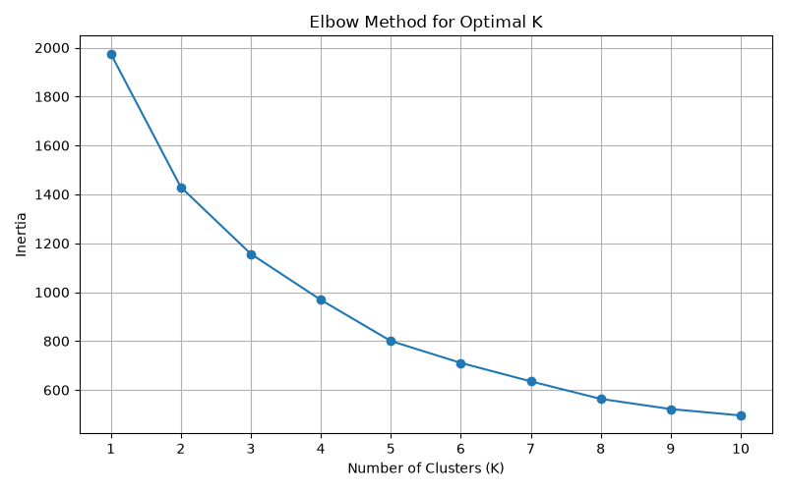
Figure 1: Elbow Method for finding the number of clusters.
The inertia decreased from 1975.00 at K = 1 to 800.45 at K = 5. The curve became more gradual as the number of clusters increased.
Based on this graph, five clusters appeared to be a reasonable choice. However, the elbow was not very sharp, so I also checked the Silhouette Score.

8.2 Silhouette Score
The Silhouette Score helps measure how well the records fit within their assigned clusters compared with other clusters. A higher score generally indicates better clustering.
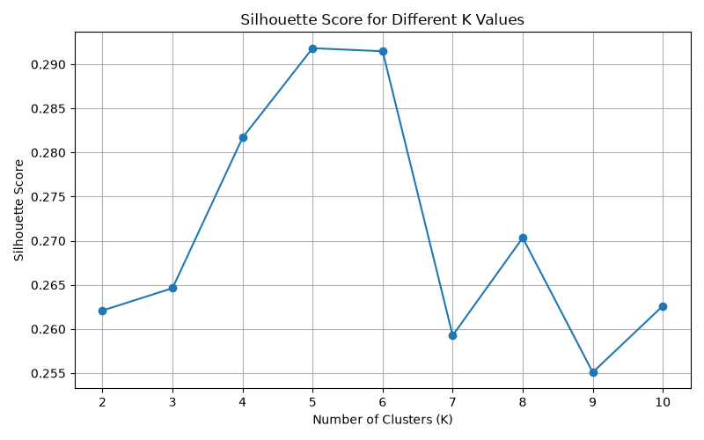
Figure 2: Silhouette Score for different K values.
The highest score among the tested values was 0.2918 at K = 5. The score at K = 6 was 0.2915, which was almost the same.
I selected K = 5 because it had the highest tested score and provided a reasonable number of groups for analysis. The scores also showed that the clusters were not very strongly separated.

9. Cluster Visualization
After applying K-Means, I created graphs to understand the distribution of students and compare their grades.
9.1 Student Clusters Based on G1 and G2
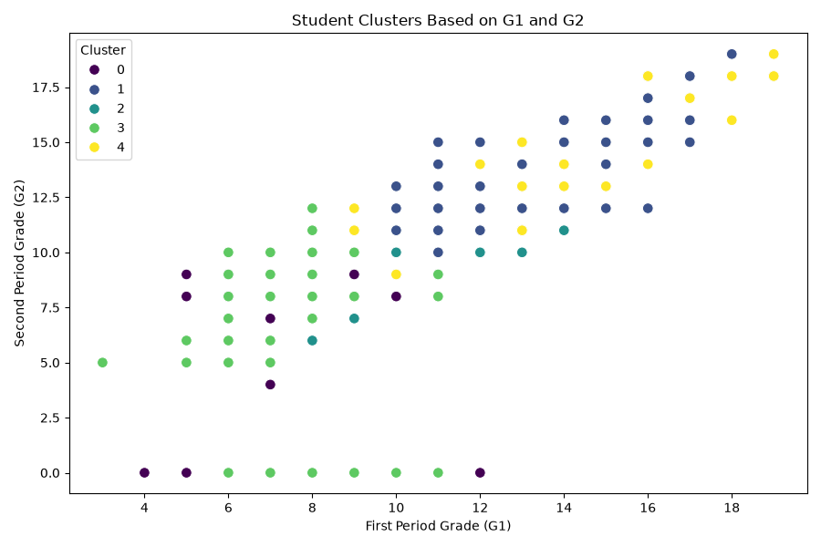
Figure 3: Student clusters based on first-period and second-period grades.
The scatter plot shows the students according to their G1 and G2 grades. Different colours represent the five clusters.
Some colours overlap in the graph. This is expected because the model used five features for clustering, but this graph displays only G1 and G2.
9.2 Number of Students in Each Cluster
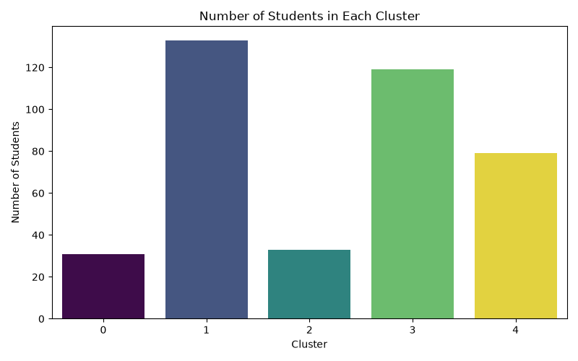
Figure 4: Number of students in each cluster.

The graph shows that Cluster 1 contained the largest number of students, with 133 records. Cluster 0 was the smallest, with 31 records.
The remaining students were divided among Clusters 2, 3, and 4. This shows that the five clusters contained different numbers of students.
8.3 Average Final Grade by Cluster
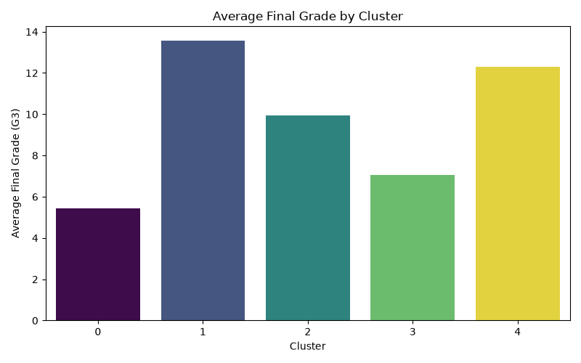
Figure 5: Average final grade for each cluster.
I compared the average final grades of the five clusters. Cluster 1 had the highest average final grade of 13.58, while Cluster 0 had the lowest average of 5.45.
This graph helped me understand how the final grades differed between the groups.
10. Cluster Profile
After assigning cluster labels, I calculated the average values of the selected features for each group. I also included G3 to compare the average final grades.
Cluster | Students | Avg. Study Time | Avg. Failures | Avg. Absences | Avg.G1 | Avg.G2 | Avg.G3
0 | 31 | 1.58 | 2.52 | 5.29 | 7.19 | 6.48 | 5.45
1 | 133 | 1.64 | 0.08 | 3.98 | 13.41 | 13.54 | 13.58
2 | 33 | 1.76 | 0.45 | 24.30 | 10.73 | 9.88 | 9.94
3 | 119 | 1.81 | 0.18 | 3.67 | 8.03 | 7.66 | 7.05
4 | 79 | 3.34 | 0.09 | 4.09 | 12.56 | 12.56 | 12.30
Note: Study-time values are averages of coded categories, not actual study hours.

10.1 Main Findings
Cluster 0: This group had the highest average number of past failures (2.52) and the lowest average final grade (5.45).
Cluster 1: This was the largest group, with 133 students. It had the highest average final grade (13.58) and a low average number of failures.
Cluster 2: This group had the highest average absences (24.30). Its average final grade was 9.94.
Cluster 3: This group had an average final grade of 7.05, even though its average number of past failures was relatively low.
Cluster 4: This group had the highest average study-time category (3.34) and an average final grade of 12.30.
These results show that the groups had different characteristics. However, they do not prove that any one feature directly caused a student's grades to increase or decrease.
11. Conclusion
In this project, I applied K-Means clustering to the Student Performance dataset using Python. I selected five features, scaled the data, and tested different numbers of clusters.
I used the Elbow Method and Silhouette Score to choose a suitable number of clusters. I selected five clusters and analysed their sizes, average grades, study-time categories, failures, and absences.
The results showed different patterns among the student groups. Cluster 1 had the highest average final grade, Cluster 0 had the lowest average final grade, and Cluster 2 had the highest average absences.
This project helped me understand how clustering works and how Python libraries can be used to analyse data. I also learned how to evaluate a clustering model, create graphs, and interpret the results.

12. Limitations
- The Silhouette Score was relatively low, so the clusters were not strongly separated.
- The results depend on the features selected for clustering.
- Study time is recorded as a category, not as exact hours.
- The cluster averages do not describe every student in a group.
- The analysis shows patterns in the data but does not prove cause-and-effect relationships.
Despite these limitations, the project provided useful practice in data preprocessing, feature scaling, K-Means clustering, visualization, and result analysis.

13. References
- UCI Machine Learning Repository. Student Performance Dataset.
https://archive.ics.uci.edu/dataset/320/student+performance
- Pandas Documentation.
https://pandas.pydata.org/docs/
- Scikit-learn Documentation — K-Means Clustering.
https://scikit-learn.org/stable/modules/clustering.html#k-means
- Scikit-learn Documentation — StandardScaler.
https://scikit-learn.org/stable/modules/generated/sklearn.preprocessing.StandardScaler.html
- Scikit-learn Documentation — Silhouette Score.
https://scikit-learn.org/stable/modules/generated/sklearn.metrics.silhouette_score.html
- Matplotlib Documentation.
https://matplotlib.org/stable/
- Seaborn Documentation.
https://seaborn.pydata.org/

